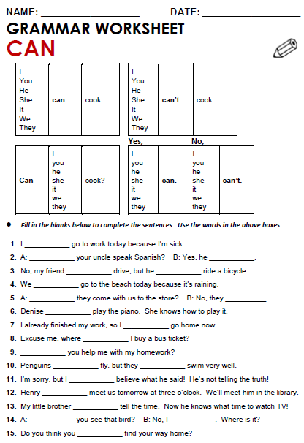

**1 Answer**

1. Can you say “Hi” in other languages?
2. Can you play sports? What sports can you play?
3. Can you write codes?
4. Can your colleague speak English?
5. Can your colleague analyse data?

**2 Complete CAN / CAN’T**

1. I ………………….go to work today because I’m sick.
2. No , my friend ……………………….drive but he ……………………..ride a motorbike
3. Yes , sure they ………………….come to the workshop, it starts at 10.
4. They ………………..design websites, they aren’t designers
5. I finish my job at 4 every day and I ……………go home
6. **Make questions CAN + PERSON+ ACTION**
7. **Answer them**

1 your coworker / fix computers?

2. you / complete the activities online?

3 you / access database from your job?

4 your friend / understand texts in English?

5 you / watch series without subtitles?